INTERNATIONAL TRAINING COLLEGE - LINGUA
Towards Educational Excellence
NCHE Reg. No: R0014
NQA Accreditation No: 000244

LANGUAGE DEPARTMENT

Assignment 2 FEBRUARY-JUNE 2024

COURSE: CERTIFICATE IN INFORMATION TECHNOLOGY - NQF LEVEL 4 : CERTIFICATE IN TRAVEL AND TOURISM - NQF LEVEL 4

: CERTIFICATE IN HEALTH CARE - NQF LEVEL 4

: CERTIFICATE IN HOSPITALITY - NQF LEVEL 4
: Certificate in Counseling NQF Level 4

DIPLOMA IN FOUDATION STUDIES NQF LEVEL 4(JP, SP, SEC AND TVET)

SUBJECT : ENGLISH

EXAMINER : C VAN WYK
MARKS

____ = _____%
35

TOTAL MARKS : 35
DUE DATE

QUESTION 1
PART 1
Read the following extract and then answer Questions below:
Read the following extract and then answer Questions 1 – 4.
Rest in Peace
The wind sweeps across the dunes, stirring up tiny horsetails of sand into the shimmering skyline. A loose piece of corrugated iron bangs in the distance, echoing across the stillness of the desert. A row of once gaily painted houses which previously belonged to a group of people who sought an evasive fortune, sink into the sand. Doors are jammed open by rivers of white sand that flow through the shadows of what were elegant parlours, dining rooms and lounges.
I am in Kolmanskop, an old mining settlement that is now a ghost town. It is on the coastal road only a few kilometres from the town of Lüderitz and to me it is one of the most fascinating and eerie places on the continent. The town was founded in 1908 when diamonds were discovered here. A massive influx of men and women made their way to this remote patch of desert that would save them from a lifetime of toil and from the disappointments of an ordinary life. Very few were that lucky. Houses sprung up alongside a butcher, a railway station and of course, the mining company offices. The new town even boasted the first X-ray machine in Southern Africa.
A melancholic beauty pervades Kolmanskop. A bathtub lying in the sand, the rattle of old panes of cracked glass looking out over a wide plain of sand and desert scrub, a wooden stairway leading to what was perhaps a child’s bedroom, now hanging over an empty patch of sand – brief glimpses into what was once luxurious lives that were led.
In its heyday around World War I and in the early 1920s, quite a number of German adults, children and an even bigger number of Ovambo workers lived there. All of their lives were centred on diamonds, diamonds and more diamonds. Well over a ton of diamonds was extracted from the dry sands before the outbreak of World War I. The discovery of larger, better-quality stones at Oranjemund further south meant that the focus of mining shifted away from Kolmanskop. By the late 1920s, it was already a ghost town, with just a handful of inhabitants hanging on as the desert slowly invaded the once bustling streets and crowded homes. The town was finally abandoned in 1956.
In the 1980s some of the houses were partially restored and a museum created. However many of the buildings are still half buried in the dunes. To wander through them is to enter a surreal world that exists partly in half-exposed memories and partly in the unique beauty of the Namibian landscape. Everyone there had been overwhelmed and yet compelled by the continent that had drawn them to this faraway outpost.
Between the extremes of the mist flowing off the icy Atlantic was the hard metallic beauty of the sun, sky and sand that burnt the mist away. Kolmanskop was a town where people lived in luxury and could enjoy extravagant parties with lots of liquor. There were miners and prostitutes who followed in their wake. It was 'however' also a town where there were frustrated housewives who experienced much loneliness being separated from their loved ones in Germany.
(Taken from TRAVEL NAMIBIA, May 2008)

Answer the following questions in your own words as far as possible.
- Why did people go to Kolmanskop in 1908? Give two reasons, using your own words.
(4)

- What is ‘melancholic’ about the beauty of Kolmanskop?
[4]
- Contrast Kolmanskop of the early 1920s with the town in the late 1920s.
[2]
- The writer paints a picture of a ‘surreal world’ in Kolmanskop. Write a paragraph in which you explain the ironies of the inhabitants’ existence in this ‘surreal world’.
[5]
[15]

PART 2
Read the following extract carefully and then answer Questions 5 – 16.

THE MAN WHO MADE SHOPPING ADDICTIVE by Lindy Woodhead
- Maverick US retailer, Harry Selfridge, had a strong belief in the power of advertising. To him, it was the engine that drove the retail machine, and his faith in it never wavered. Through good times and bad, the Selfridge policy was to spread the word through the media.
- Harry’s first aim was to get people through the store doors. “Getting them in” became his mantra. Once they were inside the store, he believed in giving them comfort, courteous service and, above all, entertainment as an enticement to buy. If, having reeled them in like fish on a line, he lost some; he reckoned he could always catch them another time.
- Brash, impulsive and imaginative, Selfridge began working in the retailing division of Chicago’s leading department store, Marshall Field, in 1885. His intention was to propose– and then implement – new ideas.
- A year or so earlier, Selfridge had been to New York – a trip apparently taken at his own expense by way of a working holiday and one which had a profound effect on him. He noted the uniformed greeters at Lord and Taylor, saw the crowds hunting for bargains at Macy’s and admired the fashionable clothes at the Bloomingdale Brothers’ East Side Bazaar. Convinced he could make his own mark on Marshall Field, Selfridge looked at what was already there and set about improving it.
- At 29, Selfridge was young enough to crave change, and astute enough to know it was waiting to happen. His first target was lighting. Despite the large central skylight, he quadrupled the number of hanging globes; he also removed the vast amounts of mahogany panelling. Then, maximising the wonder of electricity and communication, uniquely for Chicago (and very possibly any other retail store in the world), he lit the windows when the store was closed at night, bringing evening “window shopping” to the city.
- Selfridge also considered communication crucial, and increased the number of telephone lines, installing a central switchboard operated by female telephonists, with extensions into major departments.
- Next, he turned his attention to the fixtures. Shopping, he reasoned, should be both a visual and tactile experience, one best enjoyed in a moment of self-indulgence, enjoyment, and not requiring a sales clerk to unlock a cabinet. Therefore, he put central displays in the aisles, folding stock on tables so women could touch and feel a cashmere shawl or a pair of fine kid gloves that they were thinking of buying.
- There was no stopping the man staff called “mile-a-minute Harry”. Ever the publicist, he more than quadrupled the store’s newspaper advertising budget and booked Chicago’s first-ever full-page advertisements. The advertisements always had a story – aggressive advertising never interested Harry. He preferred to use persuasion, and the text of the advertisements was peppered with his quaint, quirky and deeply felt moral opinions. Nor would he use lurid headlines or false offers on prices.

- A typical trick of the day was to advertise delivery of “a special line at exceptional prices”. When customers arrived, they invariably found that what they wanted had mysteriously sold out but that there was something similar at a higher price. Selfridge never endorsed such trickery. He never promised more than the store could provide and he focused on “service with a smile”.
- He told the staff to treat customers “as guests when they come and when they go, whether or not they buy. Get the confidence of the public and you will have no difficulty in getting their patronage”. He was right. His message to both the public and the staff was that there was contentment, even fun, to be found in shopping (and working) at Marshall Field.
- By June, the following year, Harry G. Selfridge & Co, Chicago, opened to great fanfare, but still this was not enough to satisfy his ambition. By 1908 Selfridge was building his eponymous store in London’s Oxford Street and was about to become known as the man who changed retailing forever. Exactly as he had done at Marshall Field, Selfridge broke the established practice of folding merchandise away behind glass cabinet doors. Goods were to be freely on show throughout the internal floor space.
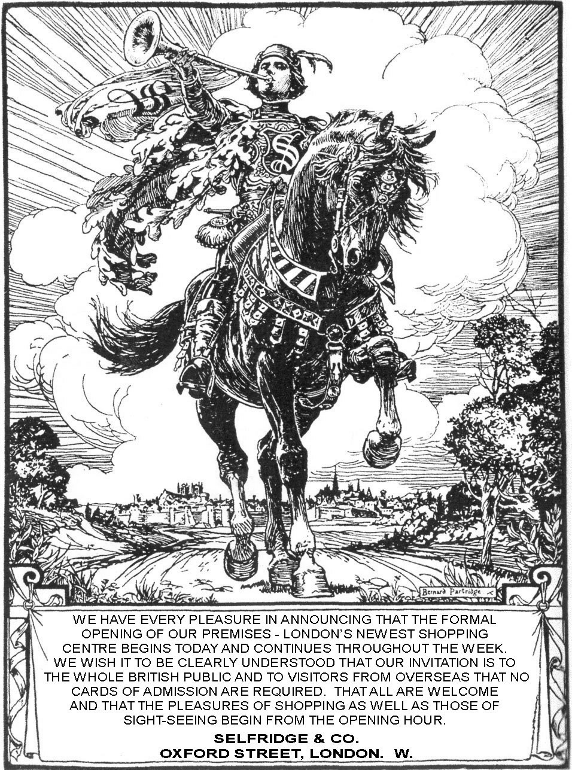

- During the opening week of his store, Selfridge hit London with an advertising campaign the like of which it had never seen. Thirty-eight richly illustrated advertisements drawn by some of the most well-known graphic artists and cartoonists, including Sir Bernard Partridge of Punch, appeared on 104 pages in 18 national newspapers. The campaign caused a sensation, with even The Times declaring it marked an epoch in the history of British retail advertising as Selfridge was prepared to spend £36 000 in 7 days to place advertisements.
- In those days, most stores merely booked a modest series of quarter-pages. Selfridge created a completely new source of income for newspapers – and they loved him for it. It was not just the sheer volume of his spending that made waves. Uniquely, Selfridge’s advertisements were not about his products: they were a mission statement about his philosophy of shopping. However, not everyone liked them. One advertising trade paper called them “high-falutin nonsense” while another dismissed them as “piffle”. Other reactions ranged from admiration to derision at Harry’s sentiment and idealism.
- In promoting the “pleasures of shopping”, in calling the store a “shopping centre” and, more significantly, in talking about “sightseeing”, Selfridge was putting into place things we take for granted today. Art exhibitions in-store? Selfridge did it in 1909. Cookery demonstrations in the kitchen equipment department? Selfridge did it in 1912. However, a hundred years ago, these were visionary ideas. It was almost as if his new friend H.G. Wells was advising H.G. Selfridge.
- Over a million people were counted into Selfridge’s during the opening week. From that moment on, both the store and the man became famous. “Selfridge”, wrote one columnist, “is as much one of the sights of London as Big Ben. With his morning jacket, white vest slip, pearl tie-pin and orchid buttonhole, he is a mobile landmark of the metropolis.”
- There was always a small crowd waiting outside to see him arrive at work each morning at 8:30am. An observer recalled, “he was received in respectable silence by the by-standers, who always waved at him.” Selfridge would doff his hat and proceed inside. He took his private lift to the fourth floor and walked briskly down the corridor lined with framed press editorials and advertising tear sheets to his north-east corner office suite. There his personal staff, Thomas Aubrey, his private secretary and two typists – would already be going through the first post of the day.
- Harry’s morning unfolded in a series of rituals, each performed with precise timing. Though he usually shaved at home, in the store the barber’s shop sent up an assistant to give him a scalp rub and trim and hot towel wrap, and to lightly wax his moustache and eyebrows, while a manicurist buffed and filed his nails.
- At precisely 9:30am, Selfridge would don his top hat and walk the store’s 24 000 square metres, the monarch of all he surveyed.
(Taken from Reader’s Digest, April 2013)

For questions 5 – 10 write down the letter A, B, C or D to indicate the answer that fits best.
- The main idea in the article is to illustrate that
  - Selfridge liked to impress people with an exaggerated lifestyle.
  - Selfridge was a visionary who knew how to lure potential customers to his store.
  - Selfridge was arrogant and liked to brag about his shop.
  - Selfridge was overly ambitious and did not care about wasting money. [1]

- The power of advertising was very important to Harry Selfridge because
A he believed it to be central in order to ensure retail success. B he thought that American retail could not survive without it. C he was a competitive businessman.
D he was the first shop owner who attached real value to advertising. [1]

- In his early years at Marshall Field, Harry Selfridge was
- aggressively confident and conservative.
- impetuous and creative.
- innovative but cautious.
- polite and generous. [1]

- Selfridge wanted shopping to be an experience in which one could touch potential purchases because
- he did not think that merchandise should be locked away.
- many shoppers should be allowed a momentary experience with the article.
- shopping would be more pleasant.
- then shoppers would be able to appreciate a specific fabric. [1]

- Selfridge never lured customers into the shop through false bargains because
- he believed in always being honest about the available stock.
- he did not want to lose the support of dedicated customers.
- he felt his staff were able to provide good customer service.
- he only wanted contentment and fun in his store. [1]

- Selfridge’s morning rituals give the reader an impression of
- his eagerness to be the best.
- his enjoyment of his work.
- his enthusiasm to impress others.
- his positive work ethic. [1]

- How does the title of the article illustrate what Selfridge wanted to achieve? [1]
- Selfridge maximised the wonders of electricity and communication. Explain how he
used these factors to make Marshall Field a very successful store. [4]
- In what way was Selfridge’s advertising approach different from that of other shop owners in Chicago? [3]
- When Selfridge opened his shop in London, what was surprising about his method of advertising? [2]
- Explain the significance of an art exhibition and a cookery demonstration in the
Selfridge shop. [2]
- Consider the picture and the text of the sample advertisement. Either support the criticism of the ‘advertising trade paper’ as “high-falutin nonsense” and “piffle” paragraph 13 or oppose it. Make one reference to the picture and one reference to
The text. [2]

[20]

