**INTERNATIONAL TRAINING COLLEGE - LINGUA**

***Towards Educational Excellence***

***NCHE Reg. No: R0014***

***NQA Accreditation No: 000095***

**LANGUAGE DEPARTMENT**

**CLASS TEST**

|  |  |
| --- | --- |
| Lecturer: C. VAN WYK | Date: AUGUST 2023 |
| QUALIFICATION : Certificate English (NQF Level 4) | |
| MODULE : English for,FOUNDATION STUDIES | |
| CLASS TEST : 1 Reading and Directed Writing | |
| TOTAL MARKS : 50 marks | |
| TIME : 1 Hour | |
| Marks Awarded : ____ = ____%  50 | |

**INSTRUCTIONS :**

* Write your full names and student number in the space provided.
* Marks are indicated at the end of each question.
* Answer each question in the space provided below.
* Write neatly and clearly
* **Cell phones** are not allowed during the test sessions.
* **N**umber of pages **6**

**Student Surname: ________________________**







**Student First name: ________________________ FT PT Distance**

**Student Number :_________________________ (*Please Tick one box only)***

**Date : ________________________**

**Section A (10 marks)**

**Reading comprehension**

**Read the following passage and answer the questions that follow.**

### Namibia

Namibia is the second least densely populated country in the world after Mongolia with a population of 2.1 million.

Many areas receive more than 300 days of sun! Winter is from June to August. I was there in August and was still wearing shorts, but it does cool down in the evening and first thing in the morning.

There are two rainy seasons. The one from September to November where there’s not as much rain, and the main one from February to April.

Until 1990, English, German and Afrikaans were the official languages. Now, the most common language is Oshiwambo, spoken by 49% of the population. The most widely understood language is Afrikaans.

Need more convincing to visit Namibia? Here are some of the most fascinating places to visit.

The Kalahari Desert in Namibia

[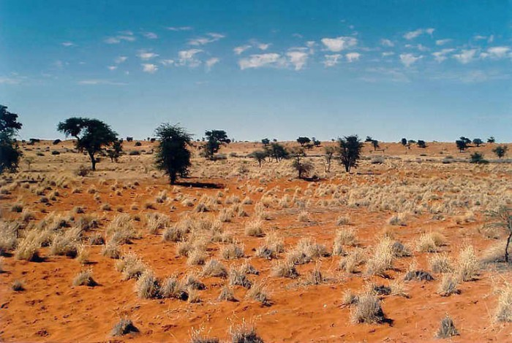](https://en.wikipedia.org/wiki/Kalahari_Desert#/media/File:Kalahari_E02_00.jpg)

Photo by Elmar Thiel, CC BY-SA 3.0

The Kalahari Desert is a bit misleading. While it’s technically a desert, it also houses highly localized environments – some of which are non-deserts!

One of the best examples is the Succulentlent Karoo. Here you’ll find an incredible 5000 different plant species. Half of which are endemic to Namibia! In addition, there is too much plant coverage for a typical desert. You’ll see what I mean.

In addition, there is too much plant coverage for a typical desert. You’ll see what I mean when we get to the Namib Desert in a bit!

Fish River Canyon

[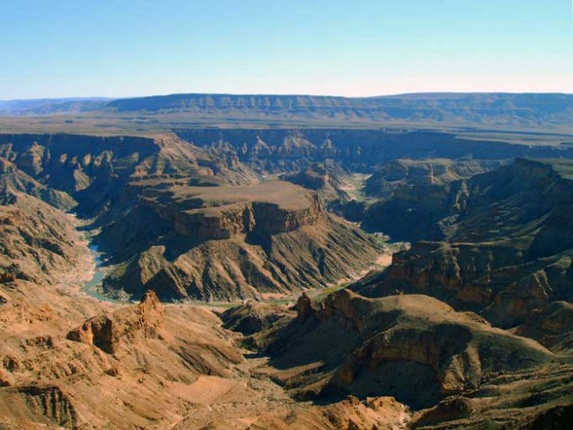](http://images.google.de/imgres?imgurl=https://upload.wikimedia.org/wikipedia/commons/6/6f/Fish-River-Canyon-1.jpg&imgrefurl=https://de.wikipedia.org/wiki/Fischfluss-Canyon&h=512&w=682&tbnid=pMDyDX-2EfY5jM:&docid=EqOv1Js0iVyuHM&hl=en&ei=ODSzVuSCK8GaPKTHs4gL&tbm=isch&iact=rc&uact=3&dur=360&page=1&start=0&ndsp=15&ved=0ahUKEwjk_tj8_t3KAhVBDQ8KHaTjDLEQrQMIJDAB)Photo by Bries via Wikimedia Commons

**Fish River Canyon is the largest canyon in Africa and the second largest in the world!** It’s 160km long, 27km wide in some places and up to 550m deep! It’s no wonder its ruggedness makes it the second most popular tourist attraction in Namibia.

I really regret not visiting Fish River Canyon on my visit to Namibia, but I wouldn’t make that mistake again if I visited. You can spend a day hiking along the rim, or go into the canyon for a real adventure!

Or if adventure is really calling, consider trekking the Fish River Canyon Hiking Trail. It’s one of the most popular hiking trails in all of southern Africa. It’s a 90km long, 5-day hike.

There are no amenities along the way and there’s no cell phone service in the canyon. There are only 2 emergency stations along the way. In other words, it’s hardcore….and calling my name! Who wants to join me?

[Source: Monkeys and Mountains Adventure Travel by Laurel Robins]

**Questions**

1. What is the population of Namibia? (1)

____________________________________________________________________

1. How many rainy seasons are there in Namibia? State the months. (3)

____________________________________________________________________

____________________________________________________________________

1. List the languages that are spoken in Namibia according to the passage. (4)
2. _________________________________________________________________
3. _________________________________________________________________
4. _________________________________________________________________
5. _________________________________________________________________
6. For each of the following, give one tourist activity that makes it worth a visit.

The Kalahari Desert

_____________________________________________________________________

____________________________________________________________________ (1)

The Fish River Canyon

____________________________________________________________________

____________________________________________________________________ (1)

1. **Vocabulary: word meanings (10 marks)**

**Give the meanings of the following words as they are used in the passage. Each correct answer scores two marks.**

1. densely _____________________________________________________________
2. convincingly _________________________________________________________
3. fascinating __________________________________________________________
4. incredible ___________________________________________________________

5. adventure ___________________________________________________________

**B: Grammar**

**Use the following words to complete the blank spaces. Choose from the given options. Each word may be used once. Each correct answer carries one mark.**

|  |  |  |  |  |
| --- | --- | --- | --- | --- |
| **changed** | **view** | **bring** | **free** | **locked** |
| **upfront** | **exchange** | **noisy** | **mini** | **reception** |

1. Can you get someone to ______________ our bags to our room?
2. Are the sheets ________________ every day?
3. We didn't take anything from the ______________________ bar.
4. I ___________________ my keys in my room.
5. Do I leave the key at the _______________ desk?
6. Do I have to pay __________________?
7. Is there somewhere I can ___________________ money around here?
8. The fan is really ___________________. Can I switch it off?
9. Is this service ____________________ or do I have to pay for it?
10. The _____________ is fantastic. We can see the whole city.

**Section B**

**Creative writing (20 marks)**

A friend of yours who lives in America has invited you for Christmas but you will not be able to go because your mother who is sick is admitted in hospital. Write a letter to your friend informing him/her why you will not be able to travel. Your letter should not be more than 200 words.

Your letter should include all or some of the following points:

* when your mother got admitted in hospital.
* What the doctors say is the problem with her.
* you are taking care of your siblings.
* When you think you will be able to travel.

________________________________________________________________________________________________________________________________________________________________

________________________________________________________________________________

________________________________________________________________________________

________________________________________________________________________________

________________________________________________________________________________

________________________________________________________________________________

________________________________________________________________________________

________________________________________________________________________________

________________________________________________________________________________

________________________________________________________________________________

________________________________________________________________________________

________________________________________________________________________________

________________________________________________________________________________

________________________________________________________________________________

________________________________________________________________________________

________________________________________________________________________________

________________________________________________________________________________

________________________________________________________________________________

________________________________________________________________________________

________________________________________________________________________________

________________________________________________________________________________

________________________________________________________________________________

________________________________________________________________________________

________________________________________________________________________________

________________________________________________________________________________

________________________________________________________________________________

________________________________________________________________________________

________________________________________________________________________________

________________________________________________________________________________

________________________________________________________________________________

________________________________________________________________________________

________________________________________________________________________________

________________________________________________________________________________

________________________________________________________________________________

________________________________________________________________________________

________________________________________________________________________________

________________________________________________________________________________

________________________________________________________________________________

________________________________________________________________________________

________________________________________________________________________________

________________________________________________________________________________

________________________________________________________________________________

________________________________________________________________________________

________________________________________________________________________________

________________________________________________________________________________

________________________________________________________________________________

**THE END**

**INTERNATIONAL TRAINING COLLEGE - LINGUA**

***Towards Educational Excellence***

***NCHE Reg. No: R0014***

***NQA Accreditation No: 000095***

**LANGUAGE DEPARTMENT**

**MEMO: CLASS TEST**

|  |  |
| --- | --- |
| Lecturer: C.VAN WYK | Date: AUGUST 2023 |
| QUALIFICATION : Certificate in FOUNDATION STUDIES (NQF Level 4) | |
| MODULE : English | |
| CLASS TEST 1 : Reading and Directed Writing | |
| TOTAL MARKS : 50 marks | |
| TIME : 1 Hour | |
| Marks Awarded : ____ = ____%  50 | |

**Section A (10 marks)**

**Reading comprehension**

**Read the following passage and answer the questions that follow.**

**Namibia**

Namibia is the second least densely populated country in the world after Mongolia. It has a population of 2.1 million.

Many areas receive more than 300 days of sun! Winter is from June to August. I was there in August and was still wearing shorts, but it does cool down in the evening and first thing in the morning.

There are two rainy seasons. The one from September to November where there’s not as much rain, and the main one from February to April.

Until 1990, English, German and Afrikaans were the official languages. Now, the most common language is Oshiwambo, spoken by 49% of the population. The most widely understood language is Afrikaans.

Need more convincing to visit Namibia? Here are some of the most fascinating places to visit.

The Kalahari Desert in Namibia

[](https://en.wikipedia.org/wiki/Kalahari_Desert#/media/File:Kalahari_E02_00.jpg)Photo by Elmar Thiel, CC BY-SA 3.0

The Kalahari Desert is a bit misleading. While it’s technically a desert, it also houses highly localized environments – some of which are non-deserts!

One of the best examples is the Succulentlent Karoo. Here you’ll find an incredible 5000 different plant species. Half of which are endemic to Namibia! In addition, there is too much plant coverage for a typical desert.

In addition, there is too much plant coverage for a typical desert. You’ll see what I mean when we get to the Namib Desert in a bit!

Fish River Canyon

[](http://images.google.de/imgres?imgurl=https://upload.wikimedia.org/wikipedia/commons/6/6f/Fish-River-Canyon-1.jpg&imgrefurl=https://de.wikipedia.org/wiki/Fischfluss-Canyon&h=512&w=682&tbnid=pMDyDX-2EfY5jM:&docid=EqOv1Js0iVyuHM&hl=en&ei=ODSzVuSCK8GaPKTHs4gL&tbm=isch&iact=rc&uact=3&dur=360&page=1&start=0&ndsp=15&ved=0ahUKEwjk_tj8_t3KAhVBDQ8KHaTjDLEQrQMIJDAB)Photo by Bries via Wikimedia Commons

**Fish River Canyon is the largest canyon in Africa and the second largest in the world!** It’s 160km long, 27km wide in some places and up to 550m deep! It’s no wonder its ruggedness makes it the second most popular tourist attraction in Namibia.

I really regret not visiting Fish River Canyon on my visit to Namibia, but I wouldn’t make that mistake again if I visited. You can spend a day hiking along the rim, or go into the canyon for a real adventure!

Or if adventure is really calling, consider trekking the Fish River Canyon Hiking Trail. It’s one of the most popular hiking trails in all of southern Africa. It’s a 90km long, 5-day hike.

There are no amenities along the way and there’s no cell phone service in the canyon. There are only 2 emergency stations along the way. In other words, it’s hardcore….and calling my name! Who wants to join me?

[Source: Monkeys and Mountains Adventure Travel by Laurel Robins

**Questions**

1. What is the population of Namibia? (1)

**2.1 million.**

1. How many rainy seasons are there in Namibia? State the months. (3)

**There are two rainy seasons. One from February to April and the other from September to November (one mark for identification of two seasons, one mark each for mentioning the period of each season).**

1. List the languages that are spoken in Namibia according to the passage. (4)
2. **English,**
3. **German,**
4. **Afrikaans,**
5. **Oshiwambo.**

**(one mark for each answer)**

1. For each of the following, give one tourist activity that makes it worth a visit.

The Kalahari desert **– while it is a desert, it has over 5000 different plant species.** (1)

The Fish River Canyon **– hiking along the rim/ going into the canyon/ trekking the Fish River Canyon Hiking Trail. (any of these)** (1)

1. **Vocabulary: word meanings (10 marks)**

**Give the meanings of the following words as they are used in the passage. Each correct answer scores two marks. Mark any other close meanings that students can come up with.**

1. densely **– heavily/ thickly/ closely.**
2. convincingly **– believably/ strongly/ realistically.**
3. fascinating **– charming/ attracting/ interesting.**
4. incredible **– unbelievably/ absurd/ far- fetched.**
5. adventure **– journey/ exploit/ escapade/ undertaking**

**B: Grammar**

**Use the following words to complete the blank spaces. Choose from the given options. Each word may be used once. Each correct answer carries one mark.**

|  |  |  |  |  |
| --- | --- | --- | --- | --- |
| **changed** | **view** | **bring** | **free** | **locked** |
| **upfront** | **exchange** | **noisy** | **mini** | **reception** |

1. Can you get someone to **bring** our bags to our room?
2. Are the sheets **changed** every day?
3. We didn't take anything from the **mini** bar.
4. I **locked** my keys in my room.
5. Do I leave the key at the **reception** desk?
6. Do I have to pay **upfront** ?
7. Is there somewhere I can **exchange** money around here?
8. The fan is really **noisy**. Can I switch it off?
9. Is this service **free**, or do I have to pay for it?
10. The **view** is fantastic. We can see the whole city.

**Section B**

**Creative writing (20 marks)**

A friend of yours who lives in America has invited you for Christmas but you will not be able to go because your mother who is sick is admitted in hospital. Write a letter to your friend informing him/her why you will not be able to travel. Your letter should not be more than 200 words.

Your letter should include all or some of the following points:

* when your mother got admitted in hospital.
* What the doctors say is the problem with her.
* you are taking care of your siblings.
* When you think you will be able to travel.

**Award marks for:**

* **Correct format of friendly letter. (4 marks)**
* **Inclusion and expansion of given points. (10 marks)**
* **Good and correct grammar. (6 marks)**

**See marking grid for allocation of mark**