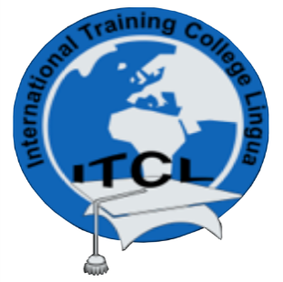
INTERNATIONAL TRAINING COLLEGE - LINGUA
Towards Educational Excellence
NCHE Reg. No: R0014
NQA Accreditation No: 000244

DEPARTMENT OF EDUCATION

MAJOR TEST 1 APRIL 2023
EXAMINER: MRS: LIMWENA

QUALIFICATION : (Diploma in Pre & JP, SP, SEC & computer Science) L 4

YEAR 1 : (Diploma in Pre & JP, SP, SEC & computer Science) L 4
COURSE/SUBJECT : INTRODUCTION TO EDUCATION

DURATION : 1 HOUR

TOTAL MARKS : 50 MARKS
INSTRUCTIONS
Write your name and student number in the space provided.
• Answer all questions in the space provided below.
- Write neatly and clearly
All Cell phones must be switched off during exam sessions
Student Name
Student Surname:

Student Number:

Date

QUESTION 1 [20]
  - Fill in the missing words, by using words in the box below
Naturalism Epistemology , Article no 20 , Article no 25 , philosophy , Ethics

______________ It explains human activities and experiences in terms of material objects and Natural laws. In other words, physical Naturalism lays more stress on the external material phenomena than the conscious human being.
______________terms of theory of knowledge, Naturalism highlight the value of scientific knowledge, through specific observation, accumulation and generalization. It also lays emphasis on the empirical and experimental
________________it declares the education rights for every Child in Namibia
- Article no 25
- Article no 24
- Article no 26
- Article no 20
1.2 State three education philosophies [6]
___________________________________________________________________________________________________________________________________________________________________________________________________________________________________________________________________________________________________________________________________________________________
1.3 List four main aims of education [8]
____________________________________________________________________________________________________________________________________________________________________________________________________________________________________________________________________________________________________________________________________________________________________________________________________________________________________________________________________________________________________________________________________________________________________________________________________________________________________________________________________________________________________________________________
Question 2 [20]
2.1 Discuss the state of Namibia education system before [1962-1990] [10]
______________________________________________________________________________________________________________________________________________________________________________________________________________________________________________________________________________________________________________________________________________________________________________________________________________________________________________________________________________________________________________________________________________________________________________________________________________________________________________________________________________________________________________________________________________________________________________________________________________________________________________________________________________________________________________________________________________
2.2 Describe Namibia education system during independence 1990-2010 [10] __________________________________________________________________________________________________________________________________________________________________________________________________________________________________________________________________________________________________________________________________________________________________________________________________________________________________________________________________________________________________________________________________________________________________________________________________________________________________________________

Question 3 [10]
3.1 Mention four policies aligned with the Namibian education system in post-independent Namibia. _________________________________________________________________________________________________________________________________________________________________________________________________________________________________________________________________________________________________________________________________________________________________________________________________________________________________________________________________________________________________________________________________________________________________________________________________________________________________________________________________________________________________________________________

