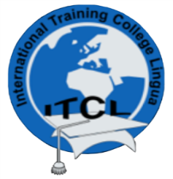
INTERNATIONAL TRAINING COLLEGE - LINGUA
Towards Educational Excellence
NCHE Reg. No: R0014
NQA Accreditation No: 000244

ASSESMENT FILE
TABLE OF CONTANTS

- Course Outline

- Work plan/Scheme of work

- Worksheet &Marking Schemes

- Assignments and Marking Scheme

- Sample of Marked Scripts

- List of learners and marks

- Analysis of Performance

