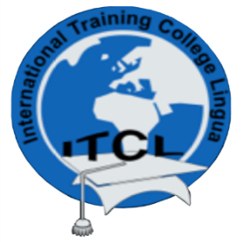
INTERNATIONAL TRAINING COLLEGE - LINGUA
Towards Educational Excellence
NCHE Reg. No: R0014
NQA Accreditation No: 000244

DEPARTMENT OF TRAVEL AND TOURISM

Lecturer: | Due Date: 22 August
QUALIFICATION : Diploma in Travel and Tourism (NQF Level 6)
YEAR 1 : 2022
MODULE : Team Management

ASSIGNMENT : 1

TOTAL MARKS : 50 marks

INSTRUCTIONS:

- Your assignment must have a cover page with your name, student number, course name and lecturer name.
- Marks awarded will be indicated both as actual and percentage.
- The assignment must be the work of the student and not shared or completed by any other student and must be typed.
- Students will be penalized for plagiarizing or simply copying passages from the study notes or web sites, other texts and from another student’s assignment/project/rough work, etc., without any referencing attached thereto.
- Students may work together but must not submit similar or identical assignments. You must be able to show that you worked independently.
- Retain a copy of each assignment before submitting it, in case the original does not reach the lecturer.
- Students who are mailing their assignments must ensure that the assignment reaches the lecturer before or on the due date.
- Assignments may NOT be submitted via fax.
- Your assignment MUST have references (APA method) written in alphabetical order.
- Use Arial -12 to type your work. Your work must be justified.
- Consult the lecturer if you do not understand assignment questions by calling 061-301032.

QUESTION 1

(a) Mintzberg (1973) developed a model of ten managerial roles. Explain each of these
[20 marks]
(b) Analyse and describe five differences between leadership and management [10 marks]
(c) The adoption of a participative approach to leadership brings many organisational
benefits. Discuss four benefits of a participative approach [20 marks]

]

5.
.

